 | 13.1.11 Editors - Shader Editor - Header - Add Menu - Utilities - Vector
Table of content
Detailed table of content 1
Add menu - Utilities - Vector 4
Combine XYZ 4
Map Range 5
Mix Vector 6
Separate XYZ 8
Mapping 8
Normal 10
Radial Tiling 10
Outputs 11
Vector Curves 11
Vector Math 13
Vector Rotate 14
Vector Transform 15

Detailed table of content
Detailed table of content
Detailed table of content 1
Add menu - Utilities - Vector 4
Combine XYZ 4
Input 4
X Y and Z 4
Output 4
Color 4
Map Range 5
Inputs 5
Value 5
From Min 5
From Max 5
To Min 5
To Max 5
Properties 5
Interpolation Type 5
Linear 5
Stepped Linear 5
Smooth Step 5
Smoother Step 5
Clamp 5
Outputs 5
Result 5
Mix Vector 6
Input 6
Float 6
Factor 6
A 6
B 6
Vector 6
Factor mode Uniform 6
Factor 6
A 6
B 6
Factor mode Non Uniform 6
Factor 6
A 6
B 6
Color 7
Factor 7
A 7
B 7
Properties 7
Data Type 7
Float mode 7
Clamp Factor 7
Vector mode 7
Factor mode 7
Clamp Factor 7
Color mode 7
Blending mode 7
Clamp Result 7
Clamp Factor 7
Output 8
Result 8
Separate XYZ 8
Input 8
Vector 8
Output 8
X, Y and Z 8
Mapping 8
Inputs 8
Vector 8
Location 8
Rotation 8
Scale 8
Properties 9
Vector type 9
Point 9
Texture 9
Vector 9
Normal 9
Outputs 9
Vector 9
Normal 10
Inputs 10
Normal 10
Properties 10
Normal Direction 10
Outputs 10
Normal 10
Dot 10
Radial Tiling 10
Inputs 10
Vector 10
Sides 10
Roundness 11
Properties 11
Normalize 11
Outputs 11
Segment Coordinates 11
Segment ID 11
Segment Width 11
Segment Rotation 11
Vector Curves 11
Inputs 11
Factor 11
Vector 11
Channel buttons 11
Curve edit field 12
Selecting Points 12
Adding Points 12
Navigation elements 12
Zoom in and out 12
Clipping 12
Tools 12
Reset View 12
Vector Handle 12
Auto Handle 12
Auto Clamped Handle 12
X / Y 13
Delete Points 13
Outputs 13
Vector 13
Vector Math 13
Inputs 13
Vector 13
Vector 13
Scale 13
Properties 13
Operation 13
Outputs 13
Vector 14
Value 14
Vector Rotate 14
Inputs 14
Vector 14
Center 14
Axis 14
Angle 14
Properties 14
Type 14
Invert 14
Outputs 14
Vector 14
Vector Transform 15
Inputs 15
Vector Input 15
Properties 15
Type 15
Convert From 15
Convert To 15
Outputs 15
Vector Output 15

Add menu - Utilities - Vector
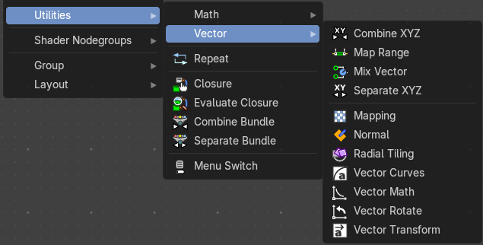
This menu contains nodes that deals with vector data.

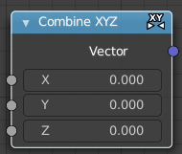
Combine XYZ
Same as with Combine RGB node. It combines color values. But instead combining rgb values, which are in the range of 0 to 255, it uses values in the range from 0 to 1.

Input

X Y and Z
X, Y and Z values.

Output

Color
Color output.

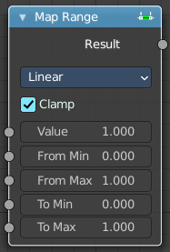
Map Range
The Map Range node remaps a value from a range to a target range.

Inputs

Value
The input value to be remapped.

From Min
The lower bound of the range to remap from.

From Max
The higher bound of the range to remap from.

To Min
The lower bound of the target range.

To Max
The higher bound of the target range.

Properties

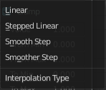
Interpolation Type

Linear
Linear interpolation between From Min and From Max values.

Stepped Linear
Stepped linear interpolation between From Min and From Max values.

Smooth Step
Smooth Hermite edge interpolation between From Min and From Max values.

Smoother Step
Smoother Hermite edge interpolation between From Min and From Max values.

Clamp
If enabled, the output is clamped to the target range.

Outputs

Result
The input value after remapping.

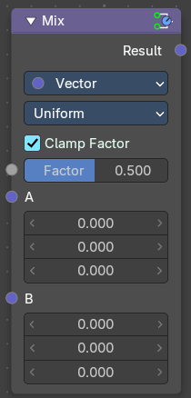
Mix Vector
A mix node with vector preselected.

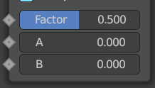
Input

Float

Factor
The mix factor.

A
Float value A input.

B
Float value B input.

Vector

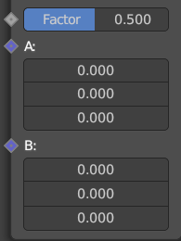
Factor mode Uniform

Factor
The mix factor.

A
Vector A input.

B
Vector B input.

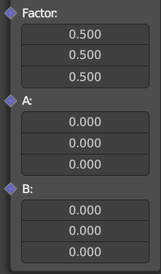
Factor mode Non Uniform

Factor
The vector mix factor.

A
Vector A input.

B
Vector B input.

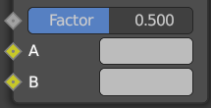
Color

Factor
The mix factor.

A
Color A input.

B
Color B input.

Properties

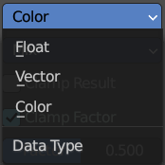
Data Type
Which mode to use.

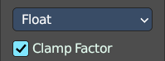
Float mode

Clamp Factor
Clamp the factor to 0-1 range.

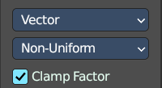
Vector mode

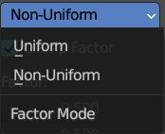
Factor mode
Uniform or non uniform factor.

Clamp Factor
Clamp the factor to 0-1 range.

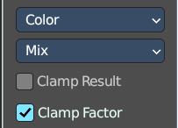
Color mode

Blending mode
What blending mode to use for the color.

Clamp Result
Clamp the result to 0-1 range.

Clamp Factor
Clamp the input factor to 0-1 range.

Output

Result
The output value or vector.

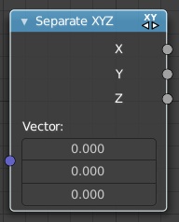
Separate XYZ
Same as with Separate RGB node. It separates color values. But instead separating rgb values, which are in the range of 0 to 255, it uses a vector with the values in the range from 0 to 1.

Input

Vector
The Input vector.

Output

X, Y and Z
The output vectors for X, Y and Z

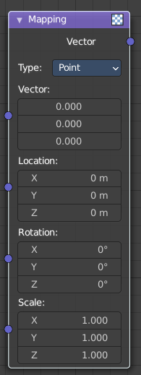
Mapping
The Mapping node transforms the input vector by applying translation, rotation, and scaling.

Inputs
The inputs of the node are dynamic. In particular, the Location input is only available in the Texture and Point vector types.

Vector
The vector to be transformed.

Location
The amount of translation along each axis.

Rotation
The amount of rotation along each axis. XYZ order.

Scale
The amount of scaling along each axis.

Properties

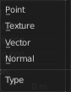
Vector type
The node applies the transformation differently depending on the semantic type of the input vector.

Point
For this vector type, the node performs a straightforward transformation.
Transforming a texture coordinates is analogous to transforming a UV map. For instance, translating the texture coordinates along the positive X axis would result in the evaluated texture to move in the negative X axis, much like if one translated a UV map. Similarly, scaling the texture coordinates up would result in the evaluated texture to scale down. So transforming the texture coordinates would appear to have the opposite effect on the evaluated texture.
The order of transformation is: Scale –> Rotate –> Translate, which means:
Translation moves the input along the local rotation axis.
Rotation rotates the input around the origin of the space.
Scaling scales the input along the global axis.

Texture
For this vector type, the node performs an inverse transformation.
Inverse transforming a texture coordinates would, as opposed to the Point type, transform the evaluated texture itself. For instance, translating the texture coordinates along the positive X axis would result in the evaluated texture to move in the positive X axis, as one would expected. Similarly, scaling the texture coordinates up would result in the evaluated texture to scale up, as one would expect.
The order of transformation is: Translate –> Rotate –> Scale, which means:
Translation moves the input along the global axis.
Rotation rotates the input around the translation vector.
Scaling scales the input along the local rotation axis.

Vector
For this vector type, a Point transformation is performed, but with zero translation.

Normal
For this vector type, the node performs the inverse transpose of the transformation and normalize the result. Such transformation ensures correct normals after non-uniform scaling. So this type should be used when transforming normals.

Outputs

Vector
The input vector after transformation.

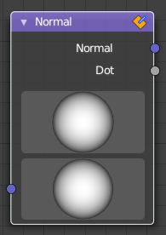
Normal
The Normal node generates a normal vector and a dot product.

Inputs

Normal
Normal vector input.

Properties

Normal Direction
To manually set a fixed normal direction vector. LMB click and drag on the sphere to set the direction of the normal. Holding Ctrl while dragging snaps to 45 degree rotation increments.

Outputs

Normal
Normal vector output.

Dot
Dot product output. The dot product is a scalar value.
If two normals are pointing in the same direction the dot product is 1.
If they are perpendicular the dot product is zero (0).
If they are anti parallel (facing directly away from each other) the dot product is -1.

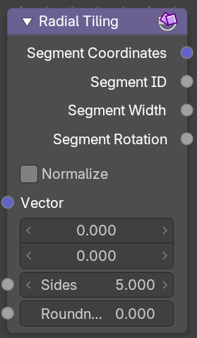
Radial Tiling

Inputs

Vector
Input vector.

Sides
Number of angular elements for tiling.

Roundness
Roundness of the segment coordinate system.

Properties

Normalize
Normalize the output to a 0/1 range.

Outputs

Segment Coordinates
Segment coordinates for texture mapping.

Segment ID
Unique ID for every segment.

Segment Width
The width of each segment.

Segment Rotation
The rotation of each segment.

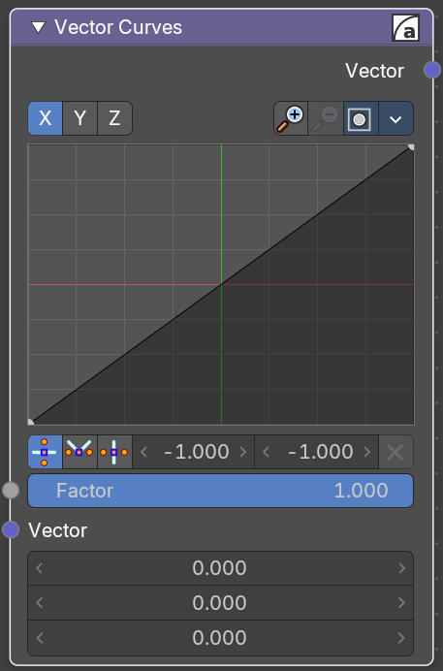
Vector Curves
The Vector Curves node maps an input vector components to a curve.

Inputs
In the shader context the node also has an additional Factor property.

Factor
Controls the amount of influence the node exerts on the output vector.

Vector
Standard vector input.
Properties
Channel

Channel buttons
X, Y, Z. Clicking on one of the channels displays the curve for each.

Curve edit field
Create and tweak a Bezier curve that varies the input levels (X axis) to produce an output level (Y axis).


Selecting Points
You can select curve points. This reveals two edit boxes for the x and y coordinate of this point.
Selected points can be moved around. Left click at them, hold the mouse button down and move them to a new location.


Adding Points
You can add new curve points by simply left clicking at the curve. Move the mouse to position them where you need it.

Navigation elements
The navigation elements at the top are described from left to right.

Zoom in and out
The two buttons with the magnifying glass at it zooms in and out in the curve window.

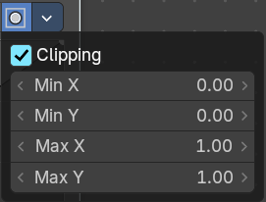
Clipping
Clipping options.

Tools
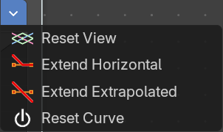
Tools is a menu where you can find some curve related tools.

Reset View
Resets the curve windows zoom.

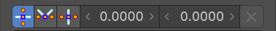
Vector Handle
Set handle type to Vector.

Auto Handle
Set handle type to Auto.

Auto Clamped Handle
Set handle type to Auto Clamped.

X / Y
The x and y position of the currently selected curve point.

Delete Points
Delete the currently selected curve point.

Outputs

Vector
Standard vector output.

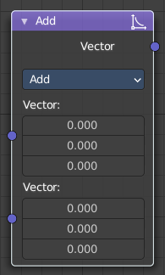
Vector Math
The Vector Math node performs the selected math operation on the input vectors.

Inputs
The inputs of the node are dynamic. Some inputs are only available in certain operations. For instance, the Scale input is only available in the Scale operator.

Vector
Input vector A.

Vector
Input vector B.

Scale
Input Scale.

Properties


Operation
The vector math operator to be applied on the input vectors.

Outputs
The output of the node is dynamic. It is either a vector or a scalar depending on the operator. For instance, the Length operator have a scalar output while the Add operator have a vector output.

Vector
Output vector.

Value
Output value.

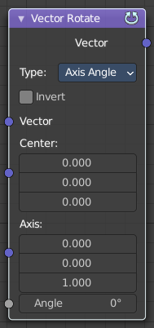
Vector Rotate
This node provides the ability to rotate a vector around a center point using either Axis Angle, Single Axis or Euler methods.

Inputs

Vector
The input vector.

Center
The center for the rotation.

Axis
The axis angles.

Angle
The rotation angle.

Properties

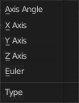
Type
The rotation type.

Invert
Invert the angle

Outputs

Vector
The output vector

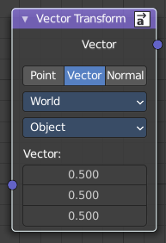
Vector Transform
The Vector Transform node allows converting a vector, point, or normal between world and camera and object coordinate space.

Inputs

Vector Input
Standard vector input.

Properties

Type
Specifies the input/output type.
Vector, Point, Normal.

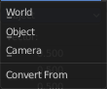
Convert From
Coordinate Space to convert from World, Object or Camera.

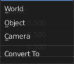
Convert To
Coordinate Space to convert to World, Object or Camera.

Outputs

Vector Output
The transformed output vector.

